UNIVERSITY OF CALIFORNIA, LOS ANGELES
Department of Electrical Engineering
EE M 171L & CS 117

Student name: _____________________

Laboratory Exercise 3: Amplitude Modulation and
Frequency Modulation

(Include with Report)

Home Work

Signal modulation is the process of encoding a baseband signal S_{m} (t) onto a carrier signal. It allows us to transmit the baseband signal over a range of frequencies near the carrier signal, and then demodulate to recover the original baseband signal.

1) What would happen if you were to transmit many baseband signals through the same medium simultaneously? How could we use modulation to successfully transmit all of these signals?

Amplitude modulation (AM) changes the amplitude of a carrier signal in direct proportion to the baseband signal.

If the baseband signal is periodic, the modulated signal can be represented by a Fourier series with terms symmetric around the original carrier frequency, which is present only if the baseband signal had a DC offset. If the carrier frequency is included in the modulated signal, it is called Dual Sideband Transmitted Carrier (DSBTC) AM.
Exercise #3: HW (continued)

If the carrier frequency is omitted in the modulated signal (DC offset of the baseband signal was zero), it is called Dual Sideband Suppressed Carrier (DSBSC) AM.

2) The carrier signal S_{c} ( t ) = A_{c} cos( 2 f_{c} t ) is amplitude modulated by a baseband square wave signal S_{m} ( t ) with amplitude A_{m} = A_{c} (varies between +A_{c} and -A_{c} ) and frequency f_{m} . Write the Fourier series for the modulated signals S( t ), for DSBTC AM (where the baseband DC offset is equal to +A_{c} ) and DSBSC AM. Include the AM constructional coefficient K_{AM} .

DSBTC

DSBSC

3) What is the power of each signal in question (2) above? Include the AM constructional coefficient K_{AM} .
DSBTC DSBSC

4) What is the absolute bandwidth of an AM signal in terms of the absolute bandwidth of the baseband signal?

Exercise #3: HW (continued)

5) What is the absolute bandwidth of each signal in question (2) above?
DSBTC DSBSC

Frequency modulation (FM) changes the phase of a sinusoidal carrier signal in direct proportion to the integral of the baseband signal over time. The effect of this integration is to change the frequency of the carrier in direct proportion to the amplitude of the baseband signal.

If the FM baseband signal is sinusoidal, the modulated signal can be represented by a Fourier series with terms symmetric around the original carrier frequency. We can use Bessel's trigonometric identities to calculate the amplitudes of each term of the Fourier series.

6) Write the formula (using Bessel functions) for the frequency modulated signal when the baseband signal is S_{m} ( t ) = A_{m} sin( 2 f_{m} t ) and the modulated signal is:

7) Write the formula for the frequency modulation index k_{f} with baseband signal S_{m} ( t ) = A_{m} sin( 2 f_{m} t ), and calculate k_{f} when:
A_{m} = 4V, f_{m} = 1000 Hz and K_{FM} = 2 x 340.

Exercise #3: HW (continued)

8) Using the formula obtained in question (6) above and the Bessel function table given in the course reader, calculate and plot the power spectrum for the frequency modulated signal with a sinusoidal carrier signal (A_{c} = 4V and f_{c} = 25 kHz) and a sinusoidal baseband signal (A_{m} = 3V and f_{m} = 1000 Hz). Assume the generator has FM constructional coefficient K_{FM} = 2 x 340. Use these figures as the theoretical prediction in Part D of the experiment.

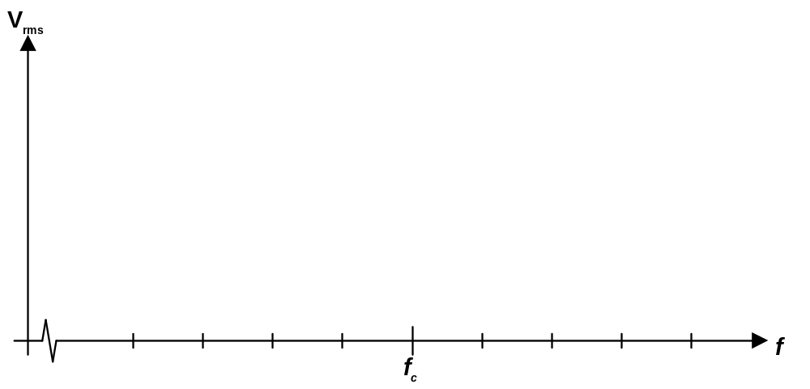

9) What is a useful approximation for the absolute bandwidth of an FM signal in terms of k_{f} and the effective bandwidth of the baseband signal?

10) Calculate the amplitudes and frequencies in the theoretical AM and FM signal spectrum for the signals mentioned in parts A, B, C and D of the experiment. In part C, calculate the spectrum assuming that A_{m} and A_{c} are already adjusted for K_{AM} . Put these calculations into the shaded boxes of the Raw Data sheets ( ).

